**Creating Microservices for account and loan**

**Account Microservice:  
AccountApplication.java:**

package com.cognizant.account;

import org.springframework.boot.SpringApplication;

import org.springframework.boot.autoconfigure.SpringBootApplication;

@SpringBootApplication

public class AccountApplication {

public static void main(String[] args) {

SpringApplication.run(AccountApplication.class, args);

}

}  
**AccountController.java**  
package com.cognizant.account;

import org.springframework.web.bind.annotation.*;

*@RestController*

*@RequestMapping*("/accounts")

public class AccountController {

*@GetMapping*("/{number}")

public Account getAccountDetails(*@PathVariable* String number) {

return new Account(number, "savings", 234343);

}

class Account {

public String number;

public String type;

public double balance;

public Account(String number, String type, double balance) {

this.number = number;

this.type = type;

this.balance = balance;

}

}}

**Output:**

<http://localhost:8080/accounts/00987987973432>  
  
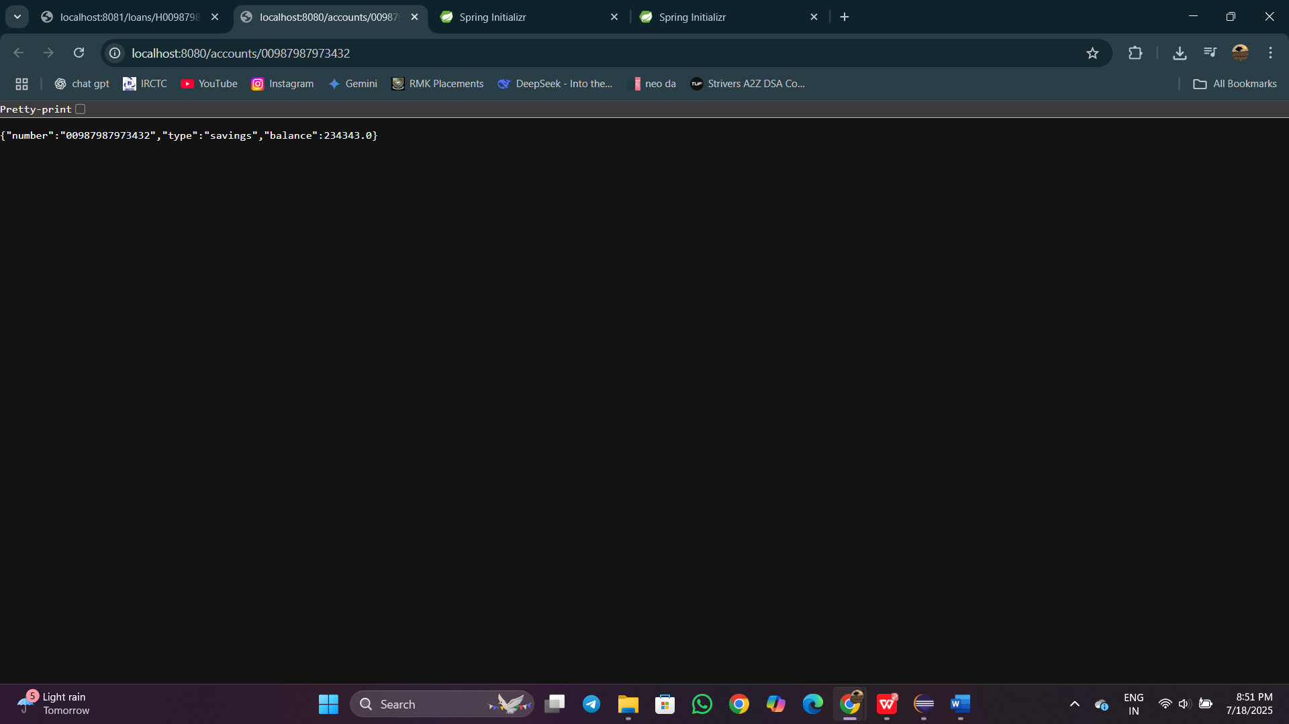

**Loan Microservice:**

LoanApplication.java

package com.cognizant.loan;

import org.springframework.boot.SpringApplication;

import org.springframework.boot.autoconfigure.SpringBootApplication;

@SpringBootApplication

public class LoanApplication {

public static void main(String[] args) {

SpringApplication.run(LoanApplication.class, args);

}

}

**LoanController.java**

package com.cognizant.loan;

import org.springframework.web.bind.annotation.*;

*@RestController*

*@RequestMapping*("/loans")

public class LoanController {

*@GetMapping*("/{number}")

public Loan getLoanDetails(*@PathVariable* String number) {

return new Loan(number, "car", 400000, 3258, 18);

}

class Loan {

public String number;

public String type;

public double loan;

public double emi;

public int tenure;

public Loan(String number, String type, double loan, double emi, int tenure) {

this.number = number;

this.type = type;

this.loan = loan;

this.emi = emi;

this.tenure = tenure;

}

}

}

**Output:**

<http://localhost:8081/loans/H00987987972342>

